Gradient Boosting Regression Notes

Introduction to Gradient Boosting
Gradient Boosting is a powerful Machine Learning ensemble technique used for both regression and classification problems. It combines multiple weak learners, usually Decision Trees, to create a strong predictive model.
The main idea behind Gradient Boosting is:
- Build models sequentially
- Each new model tries to correct the errors made by previous models
- Final prediction is the sum of all weak learners
Gradient Boosting works on the concept of:
- Additive Modeling
- Optimization using Gradient Descent
- Residual/Error Minimization

Key Idea Behind Gradient Boosting
Machine Learning models try to find a relationship between input variables (X) and output variable (Y).
A model can be represented as:
y=f(x)
Sometimes the relationship is simple and linear, but many real-world datasets contain complex non-linear relationships.
Instead of finding one complex function directly, Gradient Boosting breaks the large function into many smaller functions.
The final model becomes:
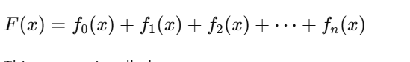This process is called:

Additive Modeling
Each new function improves the previous prediction.

Why Not Use Only Polynomial Regression?
Polynomial Regression can model non-linear relationships, but high-degree polynomials create problems such as:
- Overfitting
- Large fluctuations
- Poor generalization
This issue is known as:

Runge’s Phenomenon
Gradient Boosting solves this by using multiple small Decision Trees instead of one large complex polynomial.

Important Concepts in Gradient Boosting

1. Weak Learner
A weak learner is a simple model that performs slightly better than random guessing.
In Gradient Boosting:
- Small Decision Trees are used as weak learners

2. Additive Learning
Models are added one by one.
Each model learns from the errors of the previous model.

3. Residuals
Residuals are prediction errors.
Formula:
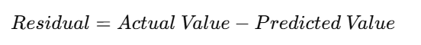
The next Decision Tree is trained on these residuals.

Gradient Boosting for Regression
Suppose we have:
- Input features (X)
- Target variable (Y)
Goal:
Find a function that predicts Y accurately.

Step 1: Initial Prediction
The first model predicts the mean of target values.
Formula:
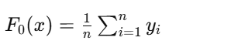
This becomes the starting prediction.

Step 2: Calculate Residuals
Residuals are calculated as:
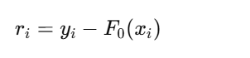
Where:
- yi​ = actual value
- F0​(xi​) = predicted value
Residuals represent errors made by the current model.

Step 3: Train Decision Tree on Residuals
A small Decision Tree is trained using:
- Inputs X
- Residuals as target values
The tree tries to predict errors.

Step 4: Update the Model
Predictions are updated by adding the new tree output.
Formula:
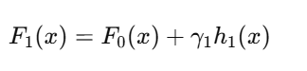
Where:
- h1​(x) = prediction from first tree
γ1​ = learning rate

General Gradient Boosting Formula
After multiple iterations:
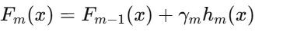
Each new tree improves previous predictions.

Loss Function
Gradient Boosting minimizes a Loss Function.
For Regression, commonly used loss function is:

Mean Squared Error (MSE)
Formula:
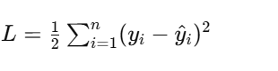
Purpose:
- Measures prediction error
- Lower loss means better model performance

Why Use 1/2 in Loss Function?
Using 1/21/21/2 makes differentiation easier because:
Derivative of square term cancels out the 2.
This simplifies gradient calculations.

Pseudo Residuals
Gradient Boosting calculates:

Pseudo Residuals
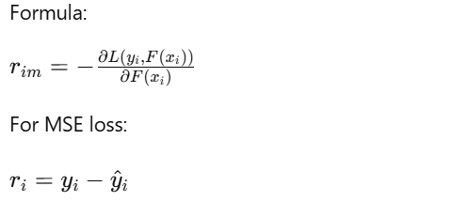
So pseudo residuals become normal residuals.

Learning Rate
Learning Rate controls how much each tree contributes.
Formula:
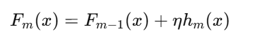
Where:
- η\etaη = learning rate
Small learning rate:
- Better accuracy
- Slower training
Large learning rate:
- Faster training
- Risk of overfitting

Terminal Regions in Decision Trees
Decision Trees divide data into regions.
Each leaf node is called a:

Terminal Region
Every terminal region contains:
- Similar data points
- Mean prediction value

Advantages of Gradient Boosting
- High predictive accuracy
- Handles non-linear data
- Works for regression and classification
- Reduces bias and error
- Supports custom loss functions

Disadvantages of Gradient Boosting
- Slower training
- Sensitive to hyperparameters
- Can overfit if trees are too deep
- Requires tuning

Applications of Gradient Boosting
- Fraud Detection
- Customer Churn Prediction
- Stock Price Prediction
- Recommendation Systems
- Medical Diagnosis
- Sales Forecasting

Important Hyperparameters
Hyperparameter | Purpose
n_estimators | Number of trees
learning_rate | Step size
max_depth | Tree depth
min_samples_split | Minimum samples to split
subsample | Fraction of data used

Common Gradient Boosting Algorithms
- Gradient Boosting Machine (GBM)
- XGBoost
- LightGBM
- CatBoost

Summary
Gradient Boosting is an ensemble learning technique where:
- Multiple weak Decision Trees are combined
- Trees are built sequentially
- Each tree corrects previous errors
- Final prediction is the sum of all trees
Core Concepts:
- Additive Modeling
- Residual Learning
- Gradient Descent Optimization
- Weak Learners
Gradient Boosting is one of the most powerful Machine Learning algorithms used in real-world AI systems.

